GENED 1104: Science & Cooking midterm 2

Thursday, November 21, 2024, 12-1:15pm Calculators permitted

Expectations
- Read the directions carefully.
- For problems involving calculation, please show your work.
- Academic Integrity:

Cheating, no matter how slight, is never acceptable.
It violates the standards of our community and disrupts learning.
A higher score is not worth compromising your integrity.

- I have not consulted anyone or any reference material
in completing this exam.
- I will not discuss exam questions and solutions
until the exam is handed back.

- I understand and agree to abide by this policy:

_______________________________________________
Name (Printed)

_______________________________________________
(Signature)

Section Time/TF (circle):

Tu 3:45  Alex | Tu 6:45  Aditya | W 3:45  Curro | Th 9:45  Tania | Th 3:45  Davide

Grading (to be completed by teaching staff)

Question | Score
1-5 | /20
6-8 | /20
9-14 | /29
15-17 | /21
18 | /10
Total | /100

Scratch Paper

Multiple Choice Questions: [20 points total]:

- Which of the following would NOT contribute to the Maillard reaction? [4 points]
  - Glucose
  - Oil
  - Lactose
  - Proteins

- In a spherical food item, what is the effect of doubling its radius on the time required for heat diffusion to reach its center? [4 points]
  - Time remains the same.
  - Time doubles.
  - Time quadruples.
  - Time increases eightfold.

- Choose the correct statement(s) (select all that apply): [4 points]
  - When you make an emulsion you are increasing the total surface energy.
  - When a foam fails due to drainage, it is caused by fluid flow due to gravity.
  - Mustard and egg yolk help stabilize emulsions due to their surfactant content.
  - When you dissolve sugar in water, you are creating an emulsion.

- The initial droplet size of an emulsion is 2 µm on average. Over time, due to Ostwald ripening, the average droplet size increases to 4 µm. What could you do to slow down this process? (select all that apply) [4 points]
  - Increase the temperature to allow more movement in the system.
  - Add a surfactant to reduce the surface tension between the phases.
  - Increase the LaPlace pressure in the smallest droplets.
  - Increase the viscosity of the continuous phase with a gelling agent.

- Which of the following statements about viscosity are TRUE? (select all that apply): [4 points]
  - Increasing the concentration of dispersed particles in a liquid increases its viscosity.
  - Heating a liquid always decreases its viscosity by reducing intermolecular forces.
  - Xanthan gum is effective as a thickener because it forms a polymer network that resists flow.
  - The viscosity of a polymer in solution is independent of the length of the polymer.

Short Answer Questions: [20 points total]

- You are performing a spherification experiment using a calcium chloride bath and sodium alginate solution. How would each of the following changes affect the spherification process:

(1) Adding lemon juice to either of the solutions. Explain why. [4 points]

Lemon juice is an acid and contains H+; H+ would bind to negative charges on alginate polymers and prevent Ca2+ from binding. So spherification would work less well.

(2) Increasing the temperature from room temperature to 60˚C for both solutions. Explain why. [4 points]

Increasing temperature increases movement of molecules so Ca 2+ would diffuse faster and spherification would occur faster. Alginate gels have a melting point of 150˚C so the gel would not melt at this temp, but we have not talked about this so this would also be a reasonable answer as long as its reasoned out completely. Also, alginate does not denature b/c it is not a protein.

- Alex is making homemade ice cream by mixing milk, cream, and sugar. During the freezing process, the components of the mixture distribute themselves across the different regions of the ice cream (air bubbles, continuous phase, and the interface). Using the diagram below, draw a line from each component to the phase where it would most-likely be found in the frozen ice cream. [6 points]

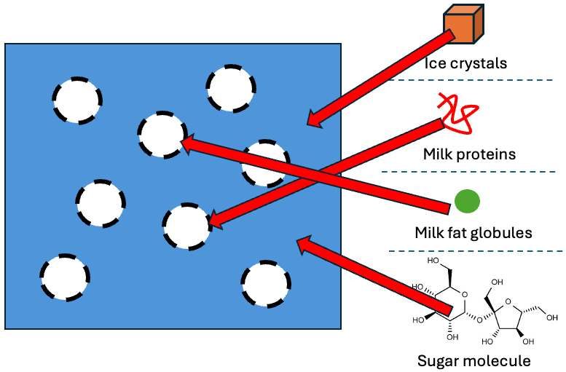

- Pia cooked her steak sous vide to 60°C, seared it, and obtained the temperature profile shown in the graph below. She then decided to further cook the steak and immediately put the already cooked steak back into a 70˚C water bath for 3 minutes. If the diffusivity of heat, D_{Heat},is 1.4x10⁻³ cm²/s, calculate how far the heat travels into the steak during the second sous vide session. Then, draw the approximate updated temperature profile on the graph below. Write down any assumptions you make. [6 points]
*sous vide means to cook something in a water bath that is kept at a constant temperature, in this case first 60˚C and then 70˚C.

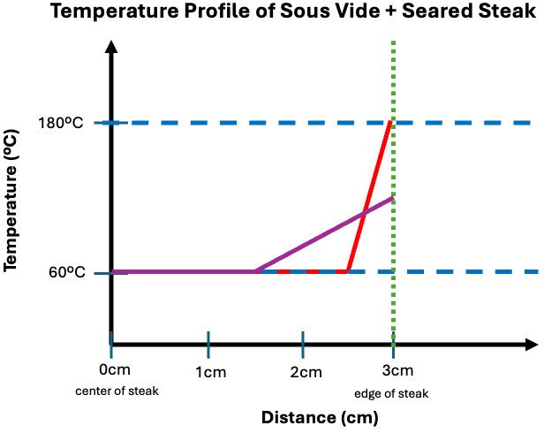

$L_{second-session}=\sqrt{4Dt}=\sqrt{4(1.4x{10}^{-3} {cm}^{2}/s)(180s)}=1 cm$
Solution is in purple. (Graph with decreased slope)

Line should:
- Remain flat at 60C in the center
- Be less than 100 at the edge
- Be at least 1 cm (if get this far should get very close to full credit), but for full credit the line should go a a little further in since the heat that was already in the steak continued to diffuse.
- Drawing a slightly curved (not straight) line is also correct

Happy Birthday Davide! [29 points total]
You are baking a birthday cake for Davide's surprise party, using a recipe that calls for flour, sugar, butter, eggs, and cream whisked into a foam-based batter. To make it extra special, you plan to top the baked cake with caramelized sugar.

- If you use 200mL of cream and 800mL of other ingredients to make the cake batter, what is the volume fraction of cream in the batter? [4 points]

$Volume fraction of cream = \frac{Volume of cream}{Total volume of batter} = \frac{200 mL}{200mL + 800 mL} = 0.2$

- After baking, you notice the cake has a soft spongy texture due to its foam structure. If you assume an air-cake interfacial surface tension of 0.05 N/m, an average air bubble radius of 0.1 cm, and an air volume fraction of 0.5, what is the elastic modulus (in Pascals) of the cake? [4 points]

$E = \frac{σ}{R}(φ-φ_{c}) =\frac{0.05 N/m}{0.001 m}(0.5-0.64)= -7 N/m^{2}=i.e. 0 Pa$
This is a negative number (partial credit for getting that number)
One additional point for realizing that negativ E means that it is not elastic (but viscous) and that therefore E =0 OR saying that other things than air contribute to E, ie the emulsion

- While preparing the revised batter, you accidentally over-whisk and incorporate 80% air. What happens to the batter’s structure compared to the air volume fraction in problem 10, and how will this affect the batter’s viscosity? [4 points]
The air bubbles become overcrowded. The batter will become more viscous and will have greater resistance to flow (increased viscosity). Saying that gluten develops is also correct but it’s not enough alone for full credit. And the final cake may actually be solid!

- Considering that egg yolk contains amphiphilic molecules, should you increase or decrease the amount of egg yolk to increase the volume fraction of air? Explain. [5 points]

The amphiphilic molecules in egg yolk allow for stabilization of the foam (and emulsion) so you should increase the amount of egg yolk to allow for more air incorporation.

- Before baking, you let the batter rest for a while and notice that its consistency changes over time. Describe two mechanisms that destabilize the batter during this period. [6 points]

- Ostwald Ripening: smaller air bubbles feed into larger ones
- Coalescence: Droplets combine to lower surface energy
- Drainage

- Davide has a sweet tooth. So after baking, you top the cake with sugar and use a torch to induce caramelization. What chemical changes occur during caramelization, and how do these changes contribute to the flavor and texture of the cake’s topping? [6 points]

- Chemical Changes: Caramelization involves the thermal decomposition of sugar at high temperatures. Sugar molecules break down into smaller compounds.
- Flavor and Texture: The chemical reactions produce complex, rich flavors, including sweet, nutty, and slightly bitter notes. The sugar forms a hard, brittle crust

Steamed Soup Dumplings [21 points]
Tania and Aditya love soup dumplings and decide to make them from scratch for their sections. They prepare the filling with minced pork, scallions, ginger, soy sauce, and solidified broth. To make the dumplings, they carefully wrap the filling in thin dumpling wrappers made from wheat flour and water. You can assume that the dumplings are spheres with a diameter of 7 cm (this includes the wrapper).
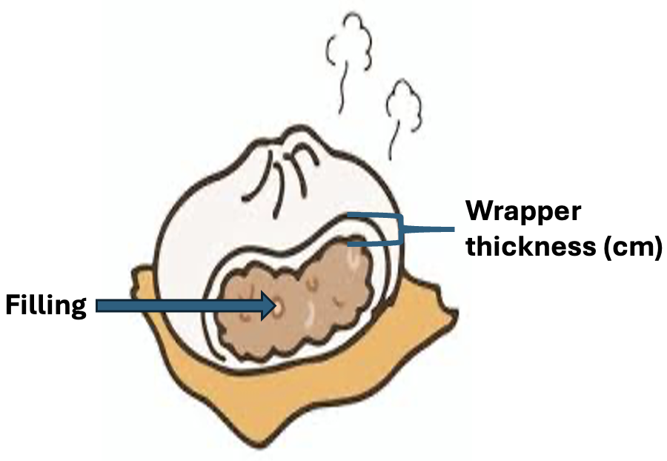

- If the dumpling wrapper is 0.15 cm thick and the heat diffusion through the wrapper is 1.9 x 10⁻³ cm²/sec. How long does it take (in seconds) for the heat to diffuse through the dumpling wrapper to the where the filling begins? [5 points]

$t= \frac{L^{2}}{4D}=t_{wrapper}=\frac{{(0.15)}^{2}}{4(1.9×{10}^{-3})}=2.96 seconds$

- The filling inside the dumplings melts to form a liquid as the dumplings steam. Assuming that the heat diffusion constant for the filling is 1.4 x 10⁻³ cm²/sec, calculate the total time (in minutes) for the filling to fully melt if you start with uncooked dumplings. [6 points]
L = 7/2 - 0.15 = 3.35 cm
$t= \frac{L^{2}}{4D}=t_{soup}=\frac{{(3.35)}^{2}}{4(1.4×{10}^{-3})}=2004 seconds$
${t_{total}=t}_{soup}+t_{wrapper}= 2.96 +2004 = 2007 secs = 33.45 minutes$

- Tania and Aditya try to make the broth more viscous by adding xanthan gum to one batch and starch to another. How do the two additives compare on a microscopic scale before and after heating? Use the boxes below, to draw, and describe with words how the two additives behave with heat. [10 points]

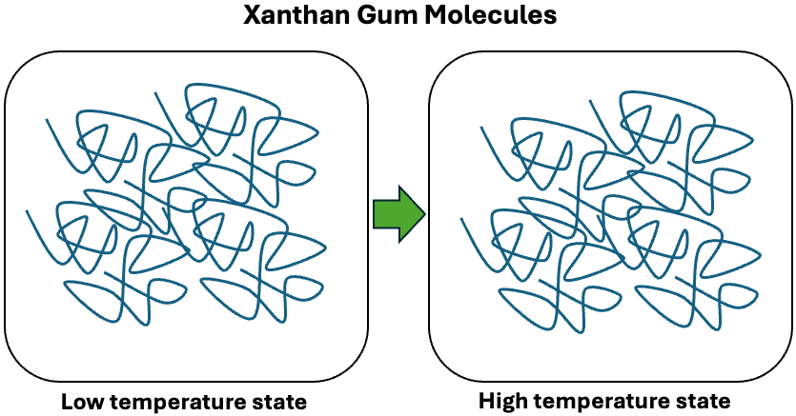

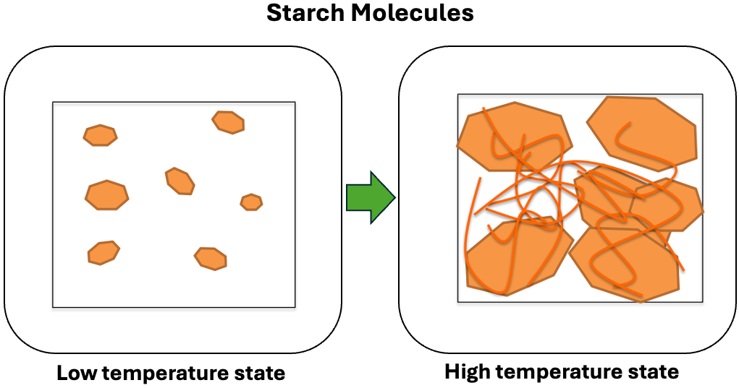

- Starch swells which increases the volume fraction AND leaks polymers which entangle
- Xanthan gum forms large entangled networks which increase viscosity and which are far less susceptible to temperature changes. Therefore the structure mainly remains unchanged, maybe slightly less H-bonding if those were added.

Low Fat Salad Dressings [10 points]
- Curro is developing a low-fat salad dressing recipe for Hidden Valley Corporation. He is creating something called a “double emulsion”. This type of emulsion consists of water droplets encapsulated in oil, which are then dispersed in an external water phase. This layered structure allows the dressing to mimic the creaminess of a high-fat product while maintaining a low-fat content.

Draw on the diagram to show where and how the surfactants in the dressing are located and label the hydrophilic and hydrophobic regions of the surfactant molecules. Then explain why the surfactants stabilize the emulsion.

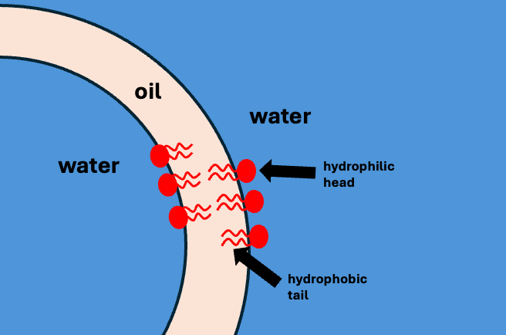

The surfactants at each interface reduce interfacial tension by stabilizing the boundaries between immiscible phases. The surfactants prevent phase separation, maintain emulsion stability, and ensure the smooth texture of the dressing.

Scratch Paper

Equation Sheet
Unit conversions
N = kg·m/s² | J = N·m |  | Pa = N/m² = J/m³ |  | 1 L= 1·10⁻³m³ |  | 1 ml = 1 cm³
Kelvin = Celsius+273 | Fahrenheit = (Celsius*9/5)+32 |  | Area circle = πr² |  | Volume sphere = (4/3)πr³ |  | Surface area sphere = 4πr²
Constants
Room temp = 23˚C |  | 1Cal = 1000 cal = 4.18 kJ |  | Gravitational acceleration  (g=-9.8 m/s²) |  | Avogadro’s number (6.022·10²³ molecules/mol)
Boltzmann constant  k_{B} = (1.38·10⁻²³ J/K) |  | Specific heat water 4.19 J/gK |  | Latent heat of vaporization for water  2260 J/g |  | Latent heat of  fusion for water  334 J/g
1 mol = 6.022 x 10²³ molecules |  | gas constant = 22.4L/mol |  | D_{heat} water  1.4⋅10⁻³ cm²/sec |  | D_{Ca} 8.0⋅10⁻¹⁰ m²/sec

Equation |  | Description | Units
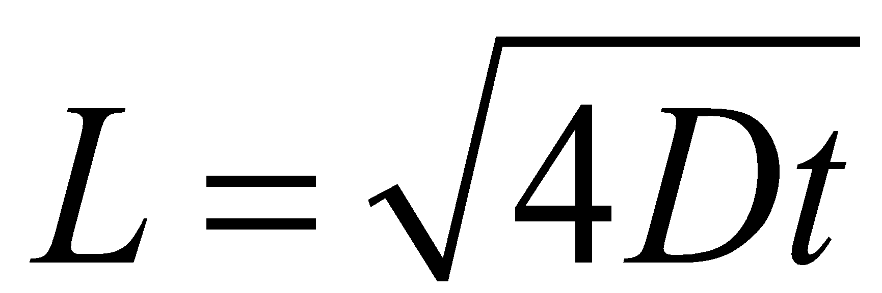 | L | Distance of diffusion | m
 | D | Diffusion coefficient | m²/s
 | t | Time to diffuse | s
$ϕ=\frac{V_{dispersed}}{V_{total}}$ | φ | Volume fraction | -
 | V_{dispersed} | Volume of dispersed phase | L
 | V_{total} | Total volume | L
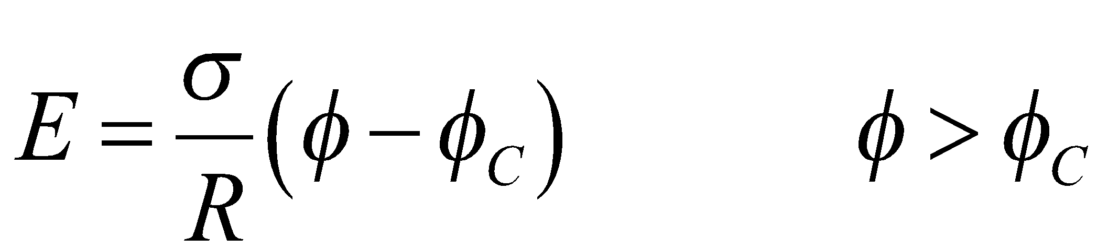 | E | Elastic modulus | Pa
 | σ | Surface tension | N/m
 | R | Droplet radius | m
 | φ | Dispersed phase volume fraction | -
 | φ_{C} | Critical volume fraction (0.64 for spheres) | -
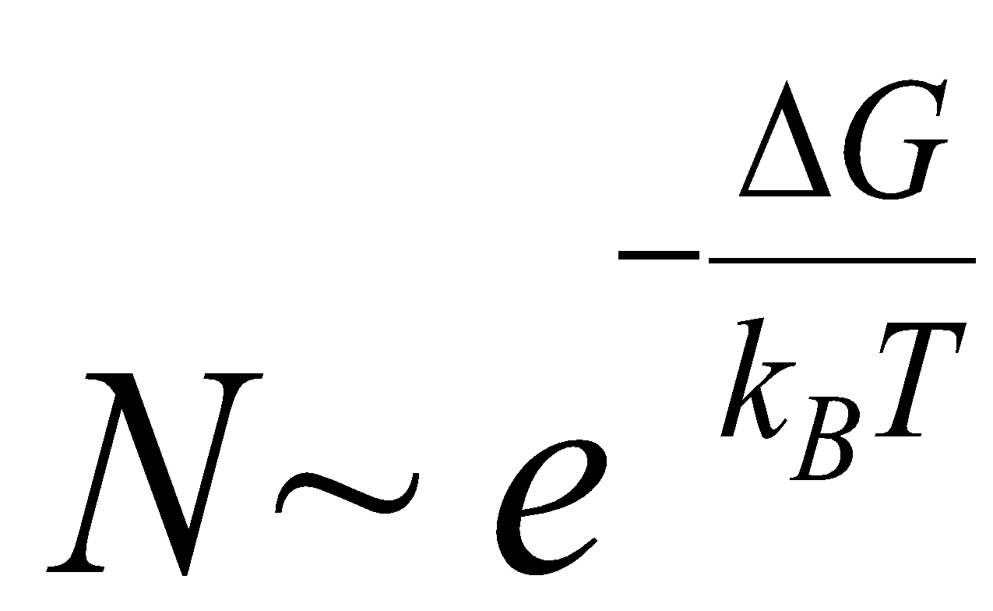 | N | Number of nuclei | -
 | ΔG | Activation energy | J
 | k_{B} | Boltzmann constant | J/K
 | T | Temperature | K

Equation |  | Description | Units
pH = -log₁₀[H⁺] | [H⁺] | Concentration of protons (also known as H⁺ ions) in solution | mol/L
 | pH | A measure of acidity | none
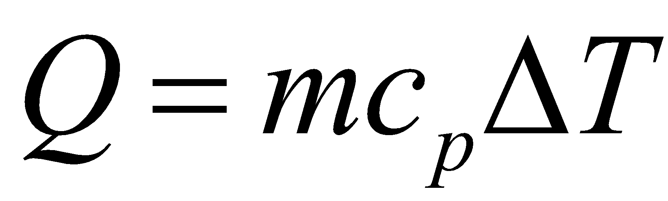 | Q | Heat | J
 | m | Mass | g
 | c_{p} | Specific heat capacity | J/g K or J/g˚C
 | ∆T | Change in temperature | K or ˚C
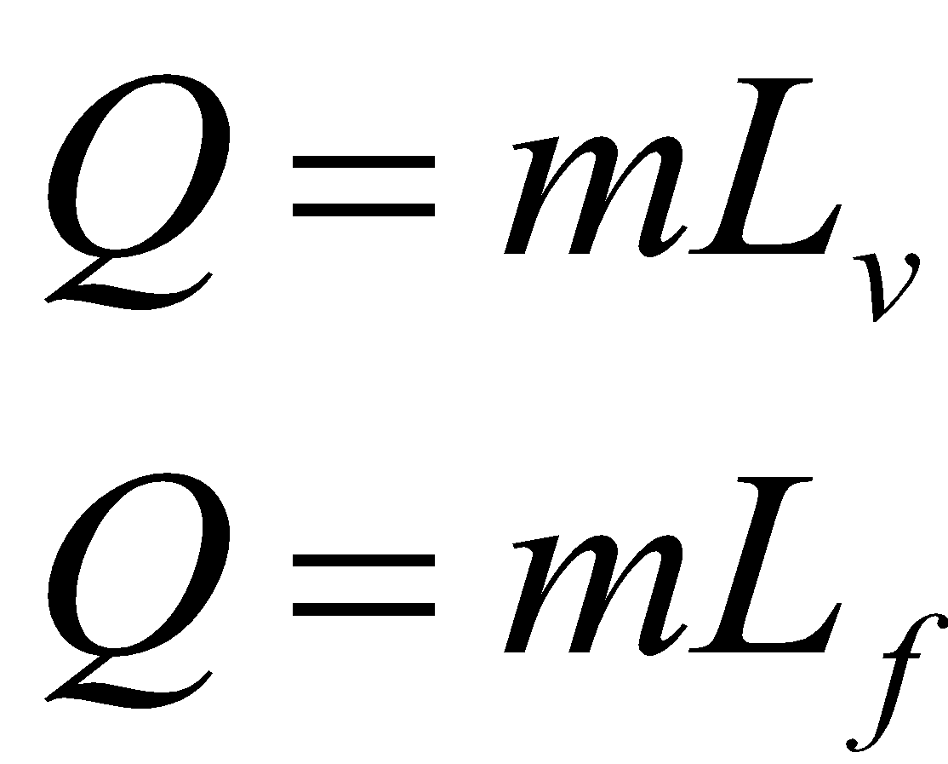 | Q | Heat | J
 | m | Mass | g
 | L_{v} | Latent heat of vaporization | J/g
 | L_{f} | Latent heat of fusion | J/g
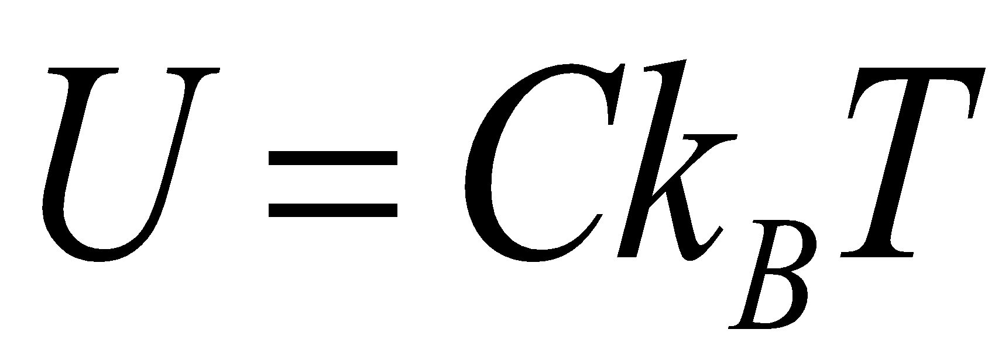 | U | Interaction energy for  liquid to gas transitions | J
 | C | Constant (1.5 for water) | none
 | k_{B} | Boltzmann constant | J/K
 | T | Temperature | K
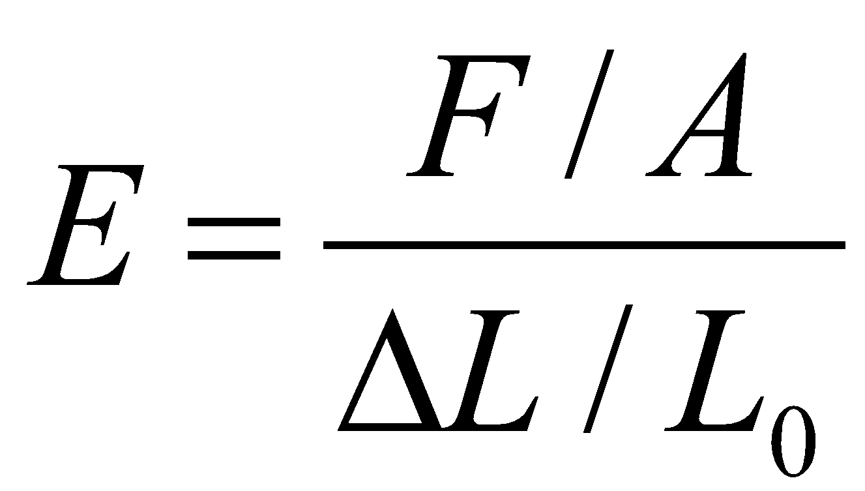 | E | Elastic modulus | Pa
 | F | Force | N
 | A | Area over which force is applied | m²
 | ∆L | Change in length | m
 | L₀ | Initial length | m
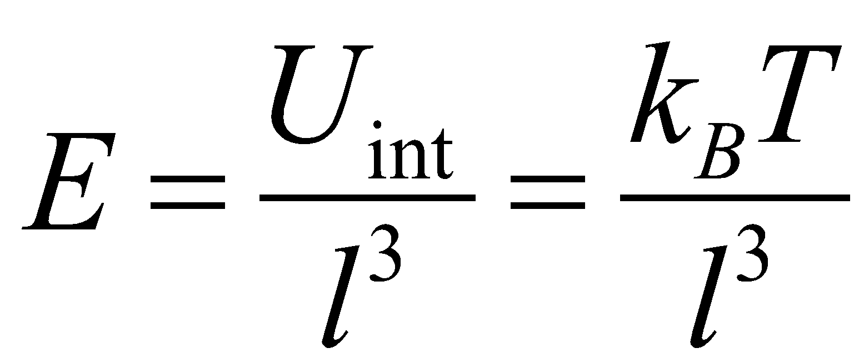 | E | Elastic modulus | Pa
 | k_{B} | Boltzmann constant | J/K
 | T | Temperature | K
 | l | Average distance between crosslinks | m
$N\left(t\right)=N_{0}e^{kt}$ where 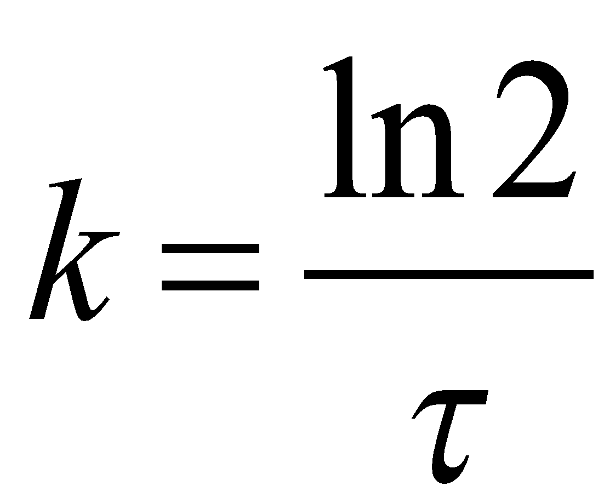 | N(t) | Number of cells at time t | microbes
 | N₀ | Number of cells at time 0 | microbes
 | k  t  $τ$ | Growth or death rate of cells  Time elapsed  Doubling time | s⁻¹  s  s

